Programming for Computer Games

Question 1 (AA1, AA2)

1. Select 2 game engines (1 mark) and list 4 reasons (1.5 marks each) why one particular game engine was selected (giving advantages of the game engine) and why the other was not selected

Engine 1: Construct 2

Engine 2: Unity

Choice: Unity

1. You can add C# scripts into a Unity game engine, while in Construct 2 that is not possible.
2. Unity has much better 2D performance than Construct 2 does.
3. Unity is better at managing complex games. With Construct 2 if you try and make a game complex, you will eventually get stuck due to the lack of proper scripting.
4. Unity is better for larger projects because the frame rate remains stable. On Construct 2, the frame rate eventually starts falling off when it comes to larger projects.
5. Select 2 programming languages (1 mark) used in game development and choose one to support the game engine chosen and list 4 of its features (1.5 marks each)

Program 1: Java

Program 2: C#

Choice: C#

Features

1. C# is object oriented.
2. It is a modern programming language.
3. It is a structured programming language (functions can be used).
4. It has a very rich class library.

Question 2 (SE1)

Prepare detailed design documents for the game:

1. One Game design document (State Diagram) should contain an overview of the whole game, from the Start Menu till the end showing correctly the interactions between the scenes
2. The second design document should contain a detailed State Diagram of either Level 2 or Level 3 of the game showing correctly all events and interactions happening in the scene

Question 3 (KU4)

In not less than 100 words, explain why compression is needed when using media assets such as images, videos and audio. Provide examples.

Compression is needed when using any sort of multimedia. First off, when media assets aren’t compressed, the game (or webpage, app) will take much longer to load than it usually does, therefore leading to dissatisfaction from the user’s side. For example, if a friend were to recommend you to visit a website, you would expect the website to load without many problems, rather than it taking ages to load. The website may also run very slowly or even have lag issues. The reason this happens is because the images and possibly videos and audio would be uncompressed, therefore making the file size of the website unnecessarily larger than if the media assets would have been compressed.

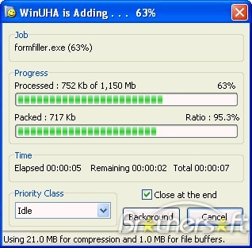

References:

<http://www.c-sharpcorner.com/article/C-Sharp-and-its-features/> - (G. Ganesh, 2001)

<https://www.javatpoint.com/csharp-features> – (JavaTPoint, unknown year)

<https://www.enginedigital.com/perspectives/2016/08/why-you-should-care-about-media-optimization/> - (G. Mesina, 2016)